Mechanical Design 2: 2244 MEMS1029 SEC1040

16 Feb 2024

Reverse Engineering of Worm and Spur Gear Motor

Danijel Babic, Gabe Noble, Matthew Bunce, Parra Wang

**Technical Summary**

The motor assembly features a gear train composed of five spur gears and one worm gear. The system includes a motor responsible for driving the rotation of the worm gear, which in turn meshes with the gear train. Two non-rotating axes within this gear train serve as pivotal points for the two intermediate gears. Additionally, one shaft aligns its rotation speed with that of the largest spur gear, contributing to the overall operational efficiency of the system.

**Detailed Design Characterization**

The Greartisan motor is crafted with an assembly of four 1018 steel spur gears, one brass spur gear and a brass worm gear.

| **Gear** | **Gear Type** | **# of teeth** | **Outside Dia. [mm]** | **Pitch Diameter** | **Module [mm]** | **Material** | **Costs** |
| --- | --- | --- | --- | --- | --- | --- | --- |
| 7 | worm | 1 | 5.5 | 2.6 | 0.5 | UNS C36000 Brass | $2.10 |
| 2 | spur | 24 | 13 | 12 | 0.5 | UNS C36000 Brass | $14.94 |
| 3 | spur | 12 | 7 | 6 | 0.5 | 1020 Steel | $3.23 |
| 4 | spur | 28 | 14.5 | 14 | 0.5 | 1020 Steel | $27.68 |
| 5 | spur | 10 | 6 | 5 | 0.5 | 1020 Steel | $7.52 |
| 6 | spur | 45 | 23 | 22.5 | 0.5 | 1020 Steel | $8.80 |

The transmission ratio of a gear train is defined as

$e = \frac{Π(gears driving)}{Π(gears being driven)}$ (1)

Using equation (1), e is found to be 0.00397 for this system. Assuming 50% loss due to friction, the Torque in can be calculated to be 0.00047 N-m, which can be interpreted as the minimum torque necessary to move the system.

**Technical Analysis: Spur Gear Force, Spur Gear Stress**

The method used to analyze each set of gears was a systematic approach using gear geometry and force analysis. As an example of this process, one may look at gears 2 and 3 within the free body diagram shown below, to the right. To the left is a general schematic of the system, with the various components labeled appropriately.

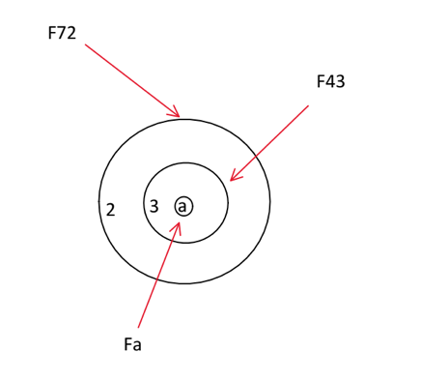

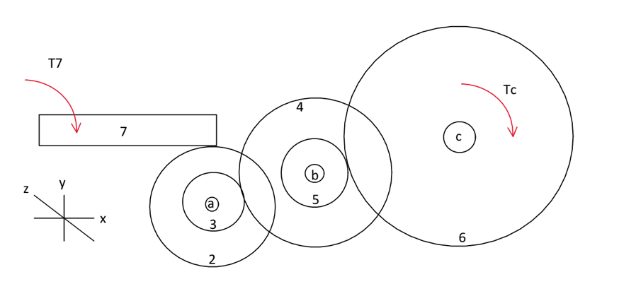

To begin finding the various components of the forces within the gear train, a good place to start would be to find at least one component of force within any gear. The easiest gear to start with is the tangential force of the output shaft. This is the case because we already know the power of the motor, $H$ as well as the speed of the output shaft, $ω$, from which we can derive the torque, $T$. Next, using the sum of moments about a specific shaft (shaft a) as well as the pressure angle of the spur gear, $ϕ$, one can determine the tangential force component on a single gear tooth. After this tangential force component is found, one can use the sum of forces within the gear and shaft to determine the remaining component forces. The mathematical process is outlined below.

$T = Hω = .53W * 8.5rpm * (\frac{2π}{60 min})= 0.0555 Nm$

$\sum{}M_{a}=0→(F_{56}^{t}*r_{6})=T$

$F_{56}^{t}=F_{56}^{x}=\frac{T}{r_{6}}⇒\frac{0.055Nm}{.023m}=4.826N$

$F_{56}=\frac{F_{56}^{x}}{cos(ϕ)}=\frac{4.826N}{cos(20°)}=5.136N$

$F_{56}^{y}=$ $F_{56}sin(ϕ) = 4.826Nsin(20°) = 1.757N$

$\sum{}F_{6}=0→F_{c}=-$ $F_{56}$

Finding the other force components in the other gears is similar to the process above. We will skip the next sets of gears for this reason and instead focus on gears 2 and 3, due to the fact that they interact with the worm gear and are more interesting to evaluate.

To begin the stress evaluation on gears 2 and 3, we will assume that all of the components of forces experienced by the gears and shaft have been found using the process above. Next, we will use the Lewis equation to find the maximum stress on a gear tooth, shown below.

$σ=\frac{K_{v}F^{x}}{WmY}$ (2)

Where $K_{v}$ is the dynamic factor for SI units and a cut or milled profile, as defined by the equation below.

$K_{v}=\frac{6.1 +V}{6.1}$ (3)

V is the pitch line velocity, defined by

$V=rω$ (4)

W is the face width in mm, m is the modulus in mm, $F^{t}$ is the tangential force component in N, and Y is the Lewis form factor, which can be found for various gear tooth numbers in *Table 14-5 (Shigley).*

The mathematical process of finding this stress for gears 2 and 3 is below. The difference for these sets of gears, as compared to the initial gear evaluation of gear 6, is that the tangential forces will be different than the original tangential force, due to the varying diameters for the gears themselves. This is also true for the radial force component.

$F_{43}^{t}=18.052N$

$F_{72}^{t}{=F}_{72}^{x}=3.0872N$

$K_{v2}=\frac{6.1 +V_{2}}{6.1}=\frac{6.1+(r_{2}ω_{2})}{6.1}= \frac{6.1+(.006*9.786)}{6.1}=1.0096$

$σ_{2}=\frac{K_{v2}{F^{x}}_{2}^{}}{W_{2}mY_{2}}=\frac{(1.0096)(3.0872N)}{(.003m)(.005m)(.337)}=11.8Mpa$

$σ_{3}=\frac{K_{v3}{F^{x}}_{3}^{}}{W_{3}mY_{3}}=\frac{(1.0048)(18.052N)}{(.00195m)(.005m)(.245)}=75.9Mpa$

**Technical Analysis: Worm Gear**

The worm analysis is perhaps the most complex and troubling analysis in this report. Referencing the 3D FBD shown below on the left, we can visualize the multi-directional force applied on the worm tooth at one point. The figure on the right is from Shigley’s Mechanical Engineering Design, and illustrates the location of $ϕ_{n}$ and $λ$ for future reference.

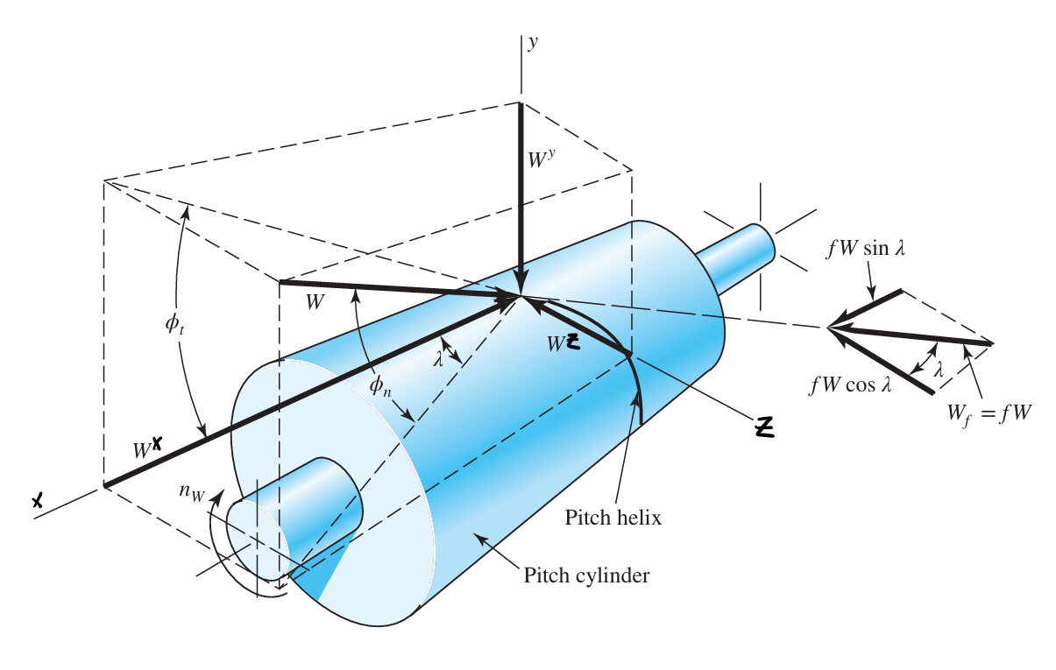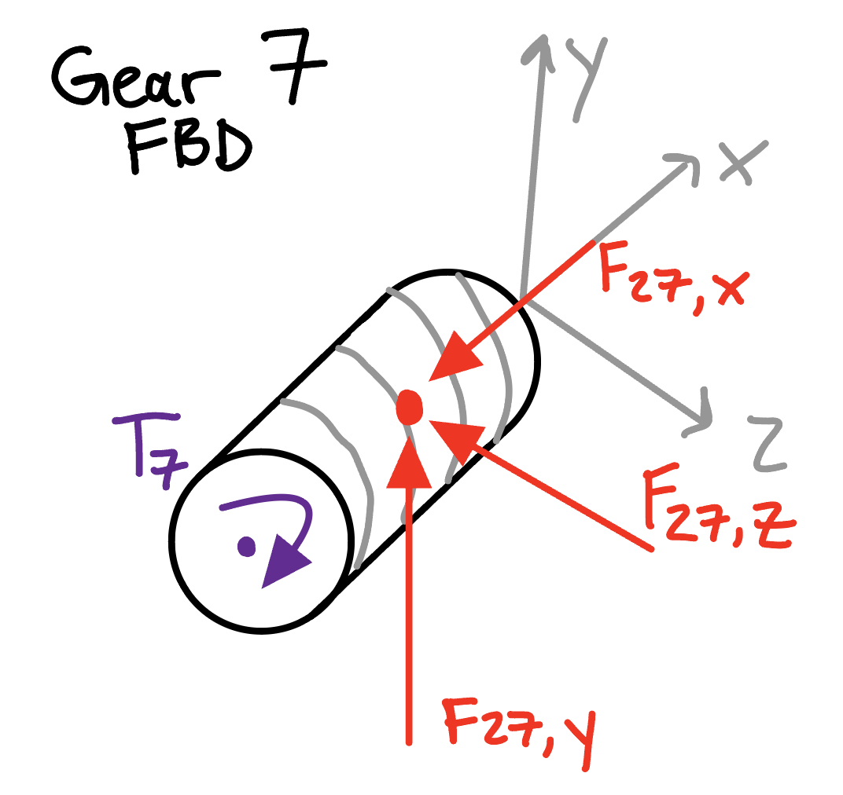

Accounting for the direction of gear 2, as seen in previous analysis, the worm gear must be torqued clockwise about the positive x axis, illustrated with T7. This is the input torque straight from the motor into the rest of the gearbox.The force of gear 2 onto gear 7 is felt in all three directions. For the sake of simplicity, the z-component was neglected in the analysis of gear 2, as it was assumed to have contributed negligible force. The magnitude of F27 is equivalent to F72, which was found earlier. From this, the tangential force on the worm tooth F27,z can be calculated using the below equation.

$F_{27,z}=F_{72}(cos(ϕ_{n})sin(λ) +f*cos(λ))$

*where $ϕ_{n}$ = pitch angle of the worm, f = coefficient of friction, and $λ$ = lead angle*

For this equation, $ϕ_{n}$ is assumed to be 20 degrees, *f* is assumed to be 0.05, and $λ$ is found from the lead. The lead is equivalent to the axial pitch for a 1-thread worm. This quality was measured to be 1.25mm, and the following equation gives the relationship for $λ$:

$λ=\tan^{-1}(\frac{L}{π * d_{w}})$

*where L = lead = axial pitch, dw = pitch diameter of the worm*

Solving these two equations allows for F27,z to be found. With this tangential force, T7 can easily be calculated as:

$T_{7}= F_{27,z}(\frac{ d_{7}}{2})$.

Now, for the stress on the gear teeth, a modified Lewis equation can be used to account for a worm, as seen in equation (5) below.

$σ_{a}=\frac{W_{G}^{t}}{p_{x}cos(λ)F_{e}y}$ (5)

*where $σ_{a}$ = max stress on gear tooth, $W_{G}^{t}$ = tangential force on worm gear = F72,x, px = axial pitch, Fe = effective face width of gear = 0.67*d7, y = shape factor = 0.125 for $ϕ_{n}$ = 20 degrees.*

Therefore, the maximum stress on the gear teeth as well as the input torque from the motor can be estimated using the methods outlined in this section. The numerical results of these calculations are found in Table 1.

**Technical Analysis: Shaft Force, Shaft Stress**

In order to find the max stress on each shaft, we will walk through an analysis of shaft a. Before we start the analysis, it is worth noting that although we are referring to them as shafts, the gears on shafts a and b spin freely, meaning that they actually act as axles instead of shafts, and no torque is transmitted through them. Shaft c, however, does experience torque and is a true shaft. We begin by creating a free body diagram of shaft a, idealizing as a simply supported beam with point loads acting on it that represent the force from each gear on the shaft. These gear forces act halfway through the thickness of the actual gear. The length of shaft a is taken from measuring the distance between the two points at which the shaft contacts the motor casing when fully assembled.

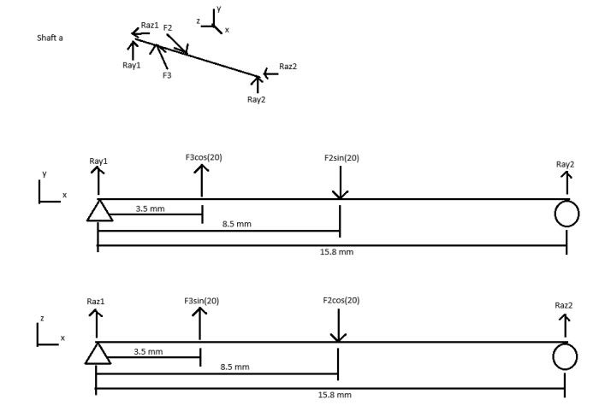

In the diagram, F2 is the force from gear 2 acting on the shaft. Since gear 2 interacts with the worm gear, the force actually comes in at 20 degrees from the z-axis instead of 20 degrees from the y-axis like all of the forces from the other gears. All this means is that for this gear’s y and z force components, sine will be used instead of cosine and vice versa. For both fbd’s, we can assume static equilibrium and use the sum of moments and sum of forces in the y and z directions to solve for each of the reaction forces. These reaction forces can then be used to find the internal shear and moment at any point in the beam in each of the y and z directions by making a cut and applying equilibrium. We can find the maximum moment experienced by the shaft by taking the square root of the sum of the moments in the y and z direction squared, and comparing that value at different points along the shaft. Once the maximum moment is found, we can use the shaft diameter to find the maximum bending stress in the shaft. We also want to find the shear stress at that location, which can be found the same way the maximum moment was found. The process is as follows (for the y direction):

Sum of moments about pin support: solve for Ray2.

Sum of forces in y direction: solve for Ray1.

Make a cut just before F2. Use the sum of moments and forces equations: solve for May2 and Vay2.

Repeat this for a cut made just before F3. Repeat the process in the z direction. Solve for the maximum moment at 3.5mm from pinned support:

$M_{a3}=\sqrt{{M_{ay3}}^{2}+{M_{az3}}^{2}}$

Find the maximum moment at 8.5mm from the pinned support as well, and then compare the two values. Use the greater of the two, Mmax, as well as the diameter of the shaft, da, to find the maximum bending stress. Equation for maximum bending stress for a solid circular shaft: solve for 𝜎b.

(6)

Then, solve for the maximum shear stress due to shear force at the location that had the maximum bending moment. Find the maximum shear force, V at that location using the same equation used to find the maximum bending moment. Equation for shear stress: solve for τ.

$τ_{}=\frac{V}{π(\frac{d_{a}}{2})^{2}}$ (7)

Now that we have the maximum bending stress in the shaft and the shear stress at that location, we can find the principal stresses acting on the shaft using the following equations for Mohr’s circle.

$σ_{avg}=\frac{σ_{x}+σ_{y}}{2}$

$R=\sqrt{(σ_{x}-σ_{y})^{2}(\frac{1}{4})+{τ_{xy}}^{2}}$

$σ_{1}=σ_{avg}+R$

$σ_{2}=σ_{avg}-R$

$τ_{max}=R$

To use these equations, we will say that σx = σb, σy = 0, and τxy = τ. We will also denote the factor of safety (FoS) for the shafts as being equal to the yield stress of the shaft material, steel, divided by the maximum principal stress experienced by the shaft. The numerical results of these values can be found in the table below.

| σb | τ | σ1 | σ2 | τmax | FoS |
| --- | --- | --- | --- | --- | --- |
| 30.9 MPa | 2.8 MPa | 31.1 MPa | -0.2 MPa | 15.7 MPa | 6.6 |
| 157.7 MPa | 14.6 MPa | 158.0 MPa | -0.3 MPa | 79.2 MPa | 1.3 |
| 3.4 MPa | 13.4 MPa | 15.2 MPa | -11.8 MPa | 13.5 MPa | 13.5 |

It is worth noting that since shaft c, unlike shafts a and b, experienced torsion, and the torsion shaft c experienced was much greater than the shear force it experienced, the shear stress used in shaft c’s calculation is the shear stress due to torsion. This is found using the following equation:

$τ=\frac{T(\frac{d_{c}}{2})}{\frac{π}{32}(\frac{d_{c}}{2})^{4}}$ (8)

Where T is the torque undergone by shaft c, and dc is shaft c’s diameter.

**Summary**

The essential elements enabling the functioning of a worm gear motor include:

1. Worm screw: This is the threaded drive shaft linked to the motor, featuring spiral threads that interlock with the worm wheel.

2. Worm wheel: Positioned at a 90-degree angle to the worm screw, this gear incorporates teeth that engage with the threads on the worm screw.

3. Gear ratio: This is determined by the ratio of teeth on the wheel to threads on the screw, providing a mechanism for speed reduction.

As the motor rotates the worm screw, its spiral threads move against the teeth of the stationary worm wheel. Consequently, the wheel turns at a slow pace but generates high torque. The substantial gear ratio is instrumental in achieving this high torque output.

Worm gear motors offer a range of benefits that contribute to their widespread use in various applications. One notable advantage is their compact size, achieved by intersecting gears at a 90-degree angle, resulting in an exceptionally space-efficient gearbox. Additionally, these motors exhibit high torque output, thanks to their large gear reduction, enabling robust performance even with relatively small motors and this is also the reason why the sixth gear uses a thicker shaft which is responsible for larger torque output on the gear 6. Operating quietly is another key feature, attributed to the smooth meshing of the worm screw and wheel. Furthermore, worm gear motors excel in shock absorption, effectively mitigating high impact forces. Lastly, their efficiency in transmitting power between non-intersecting shafts enhances overall system efficiency, making them a versatile and practical choice in diverse industrial and mechanical settings.

It is noteworthy that brass is employed in the construction of both the worm and gear components in certain applications. The rationale behind the utilization of brass material is intricately linked to the deliberate design strategy where the mating gear of the worm is intentionally fabricated to be sacrificial. This intentional sacrificial design stems from the inherent property of brass, allowing for ease of replacement. By adopting brass for the gear, maintenance and replacement efforts are streamlined, as the gear, being the sacrificial element, can be readily substituted, ensuring operational efficiency and longevity.

In addition, a brass gasket is incorporated on the contact surface between gear 6 and the motor housing. This strategic use of brass is motivated by its inherent lubricious properties, rendering it a self-lubricating material. This characteristic diminishes the necessity for supplementary lubrication in the motor system, contributing to operational efficiency. Furthermore, the commendable thermal conductivity of brass is leveraged in dissipating the heat generated during motor operation, optimizing thermal management. The acoustic damping attributes of brass are harnessed to attenuate vibrations and mitigate noise, presenting a valuable advantage in motor applications where noise reduction is paramount. The comprehensive utilization of brass in these multifaceted capacities underscores its versatile contribution to enhancing the overall performance and reliability of the motor system.

Table 1: Gear Dimensions

| **Gear** | **Gear Type** | **# of teeth** | **Outside Dia. [mm]** | **Pitch [1/in]** | **Module [mm]** | **Yield Strength [MPa]** | **Modulus of Elasticity [MPa]** | **FoS** |
| --- | --- | --- | --- | --- | --- | --- | --- | --- |
| 2 | spur | 24 | 13 | 49.695 | 0.5 | 217 | 97000 | 35.192 |
| 3 | spur | 12 | 7 | 42.333 | 0.5 | 350 | 205000 | 6.641 |
| 4 | spur | 28 | 14.5 | 48.546 | 0.5 | 350 | 205000 | 6.641 |
| 5 | spur | 10 | 6 | 43.542 | 0.5 | 350 | 205000 | 3.725 |
| 6 | spur | 45 | 23 | 46.892 | 0.5 | 350 | 205000 | 4.843 |
| 7 | worm | 1 | 5.5 | N/A | 0.5 | 217 | 97000 | 36.676 |

Table 2: Shaft Dimensions

| **Shaft** | **Length [mm]** | **Diameter [mm]** | **Material** | **Yield Strength [MPa]** | **Modulus of Elasticity [MPa]** | **RPM** | **Torque [N-m]** | **FoS** |
| --- | --- | --- | --- | --- | --- | --- | --- | --- |
| a (axle) | 17.3 | 2.5 | 1020 steel | 350 | 205000 | 0 | 0 | 11.2 |
| b (axle) | 18.4 | 2.5 | 1020 steel | 350 | 205000 | 0 | 0 | 2.2 |
| c | 36.0 | 6.0 | 1020 steel | 350 | 205000 | 8.9 | 0.569 | 23 |

Table 3: Geartrain Analysis

| **Gear** | **Ratio** | **Force on Gear [N]** | **Shaft** | **Force on Shaft [N]** |
| --- | --- | --- | --- | --- |
| 6 | 1:24 | 53.8 | a | 30.9 |
| 5 | 2:1 | 53.8 | b | 157.7 |
| 4 | 12:28 | 19.2 | c | 3.4 |
| 3 | 28:10 | 19.2 |  |  |
| 2 | 10:45 | 3.29 |  |  |
| 7 | 24:1 | 3.29 |  |  |

**Appendix**

Free Body Diagrams

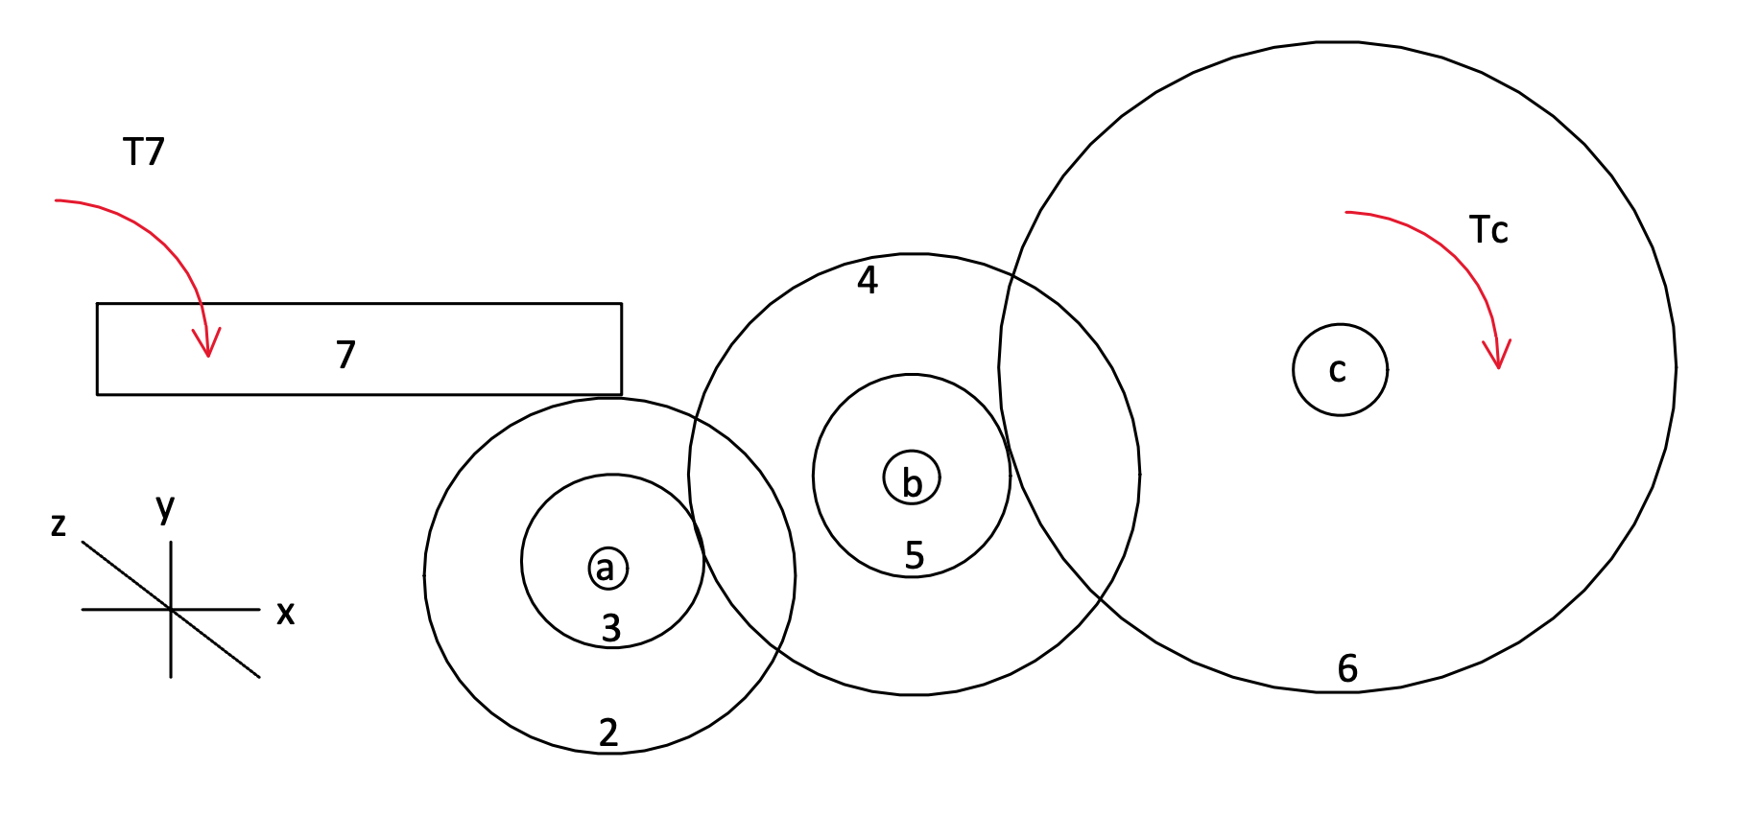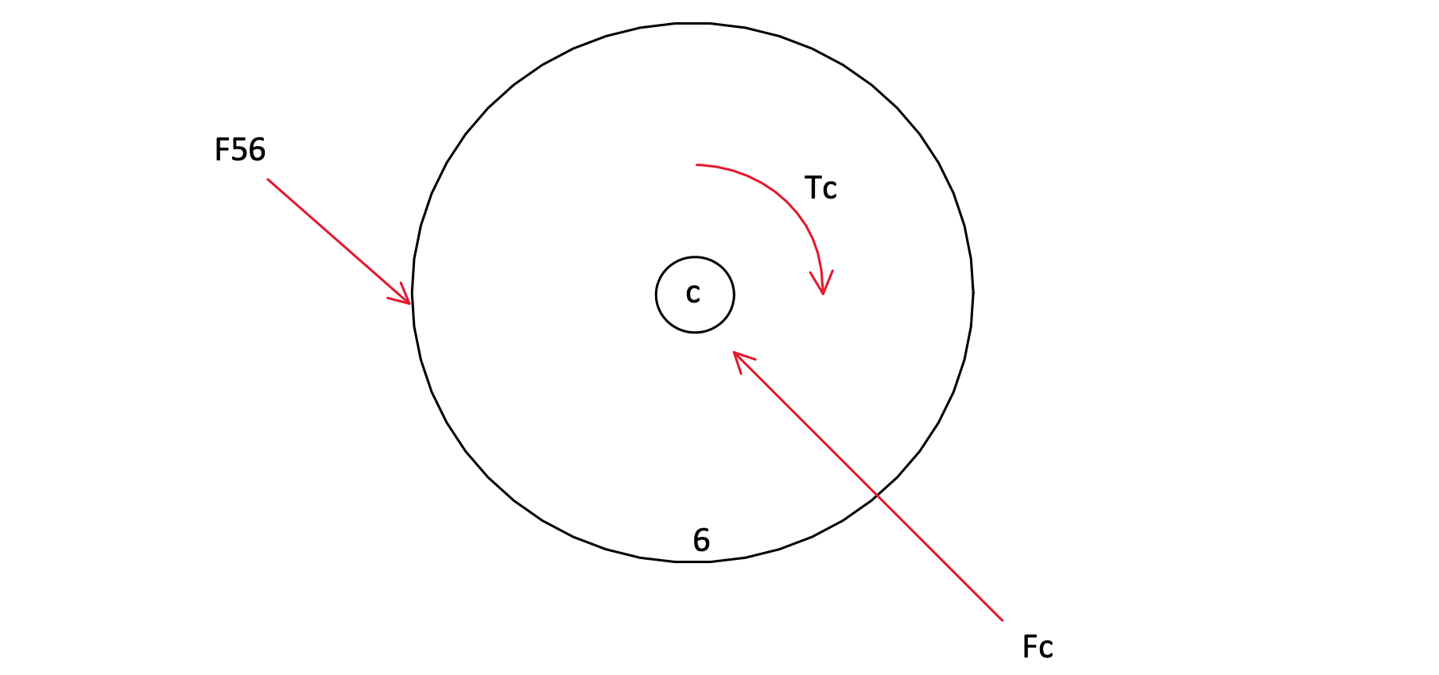

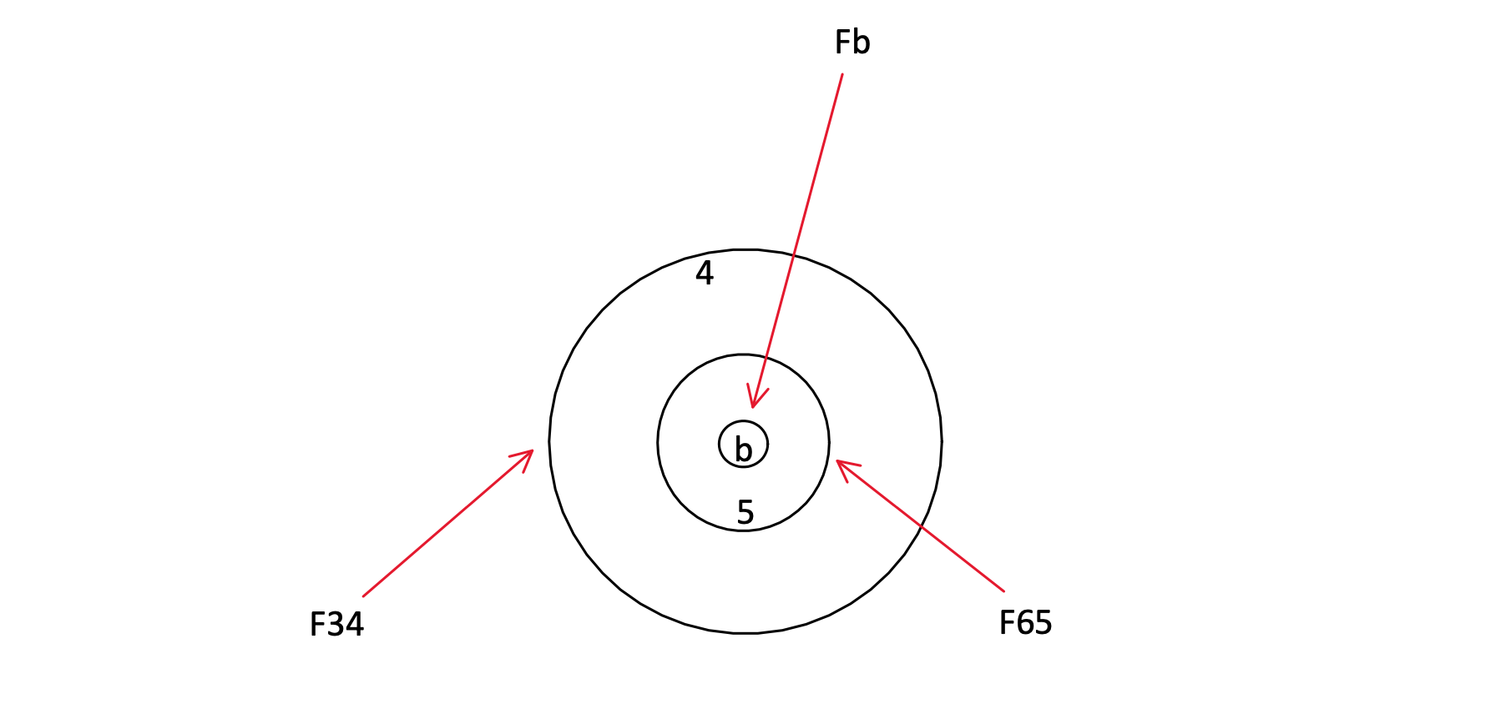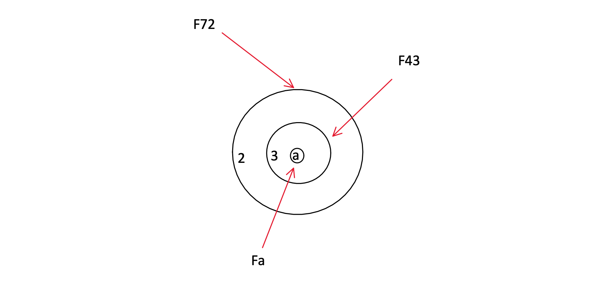

CAD Drawing

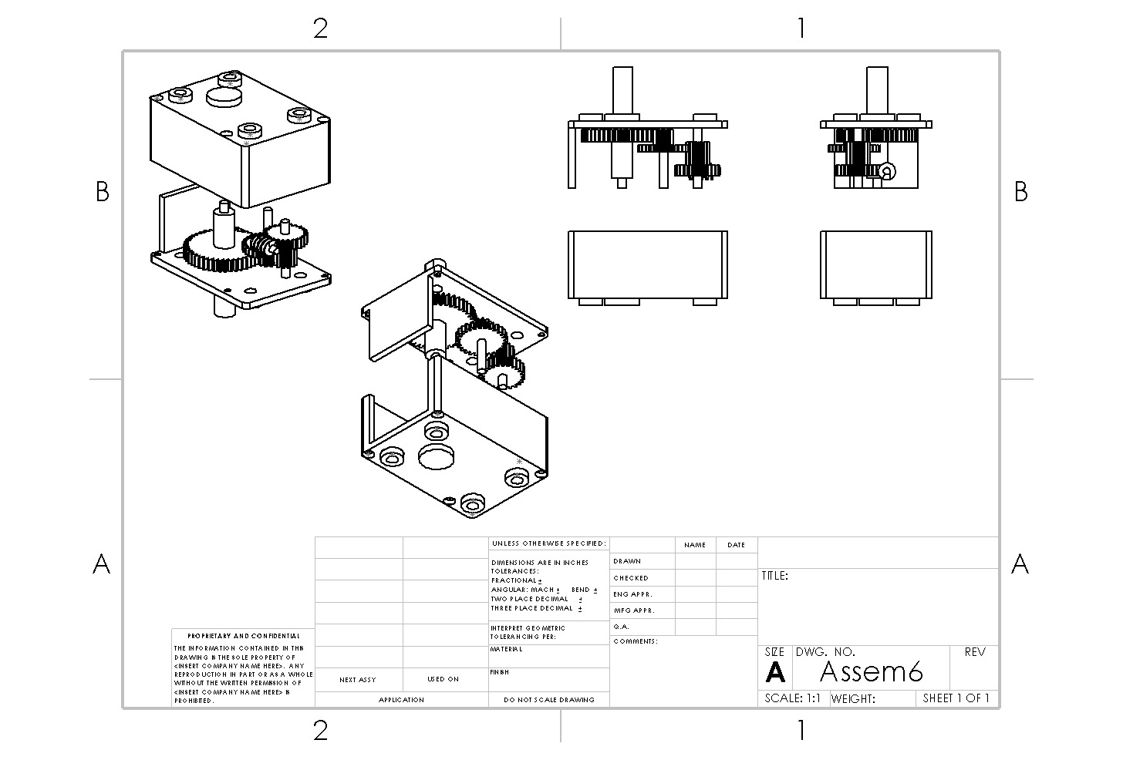

Work Breakdown

Simon: 11 hours

* Shaft force and stress analysis
* Shaft diagrams
* Shaft force and stress calculations

Gabe: 9 hours

* Worm gear force and stress analysis
* Worm gear free body diagrams
* Worm gear force and stress calculations

Parra: 11.5 hours

* Numerical based CAD of gears and shafts
* Bill of materials
* Summary
* Energy loss calculations

Dan: 13 hours

* CAD of housing and motor
* Spur gear force and stress analysis
* Spur gear diagrams
* Spur gear force and stress calculations